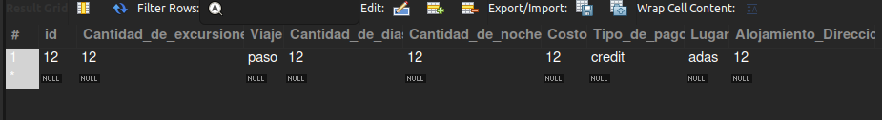
Paquete de viaje:

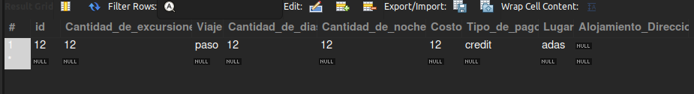
Paquete de viaje (On update SET NULL):

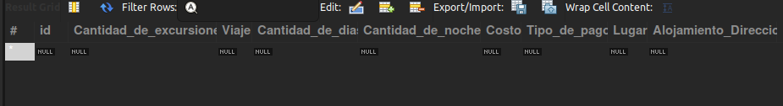
Paquete de viaje (On delete Cascade):

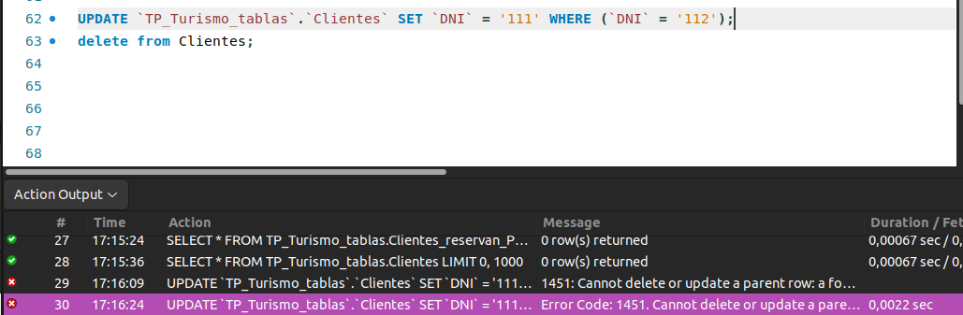
Cliente has paquete de viaje (On update Restrict):

Consultas1:

Clientes has productos (on delete restrict):
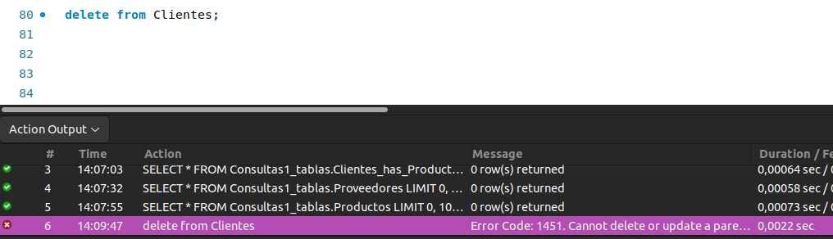

Clientes has productos (on update cascade):

